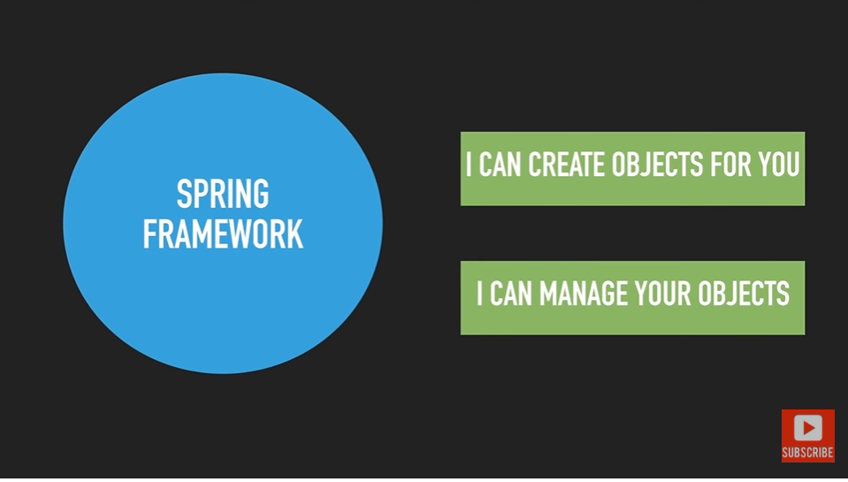

Spring says put your classes in config file so I will create object for your all classes which are present in config file.

IOC container : ioc container it will read our config file and all the classes we are mentioned in config file it will create objects for them and manage them inside the ioc container.

It will store the all this objects inside the container.

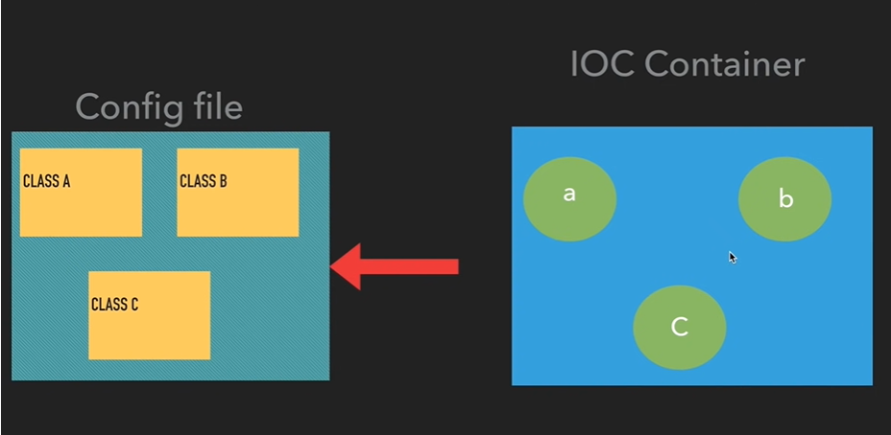

Beans : spring container create the objects we called as beans

This are the objects that is inside the IOC container.

All the objects that spring creates and manages inside the ioc container is called spring beans.

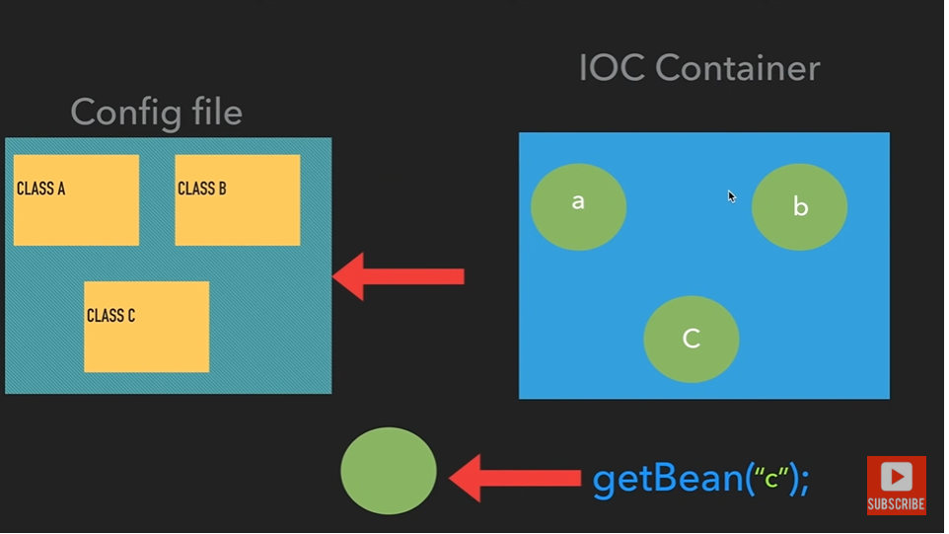

Two ways we can use IOC Container

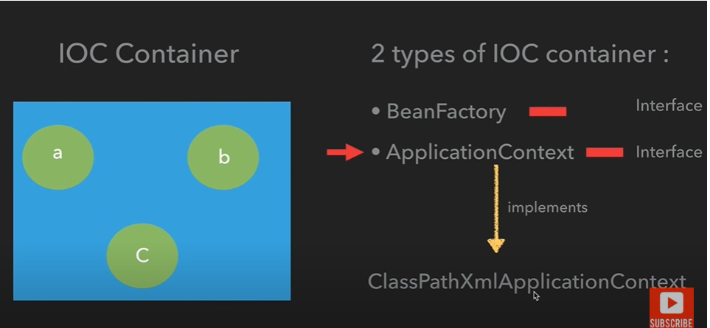

Config file : It is an xml file, inside we will define our beans (objects), which objects the spring container manages objects.

We need to mention those classes which spring container going to create objects for the classes.

We will use <bean> tag to tell that hey spring you create object for this particular bean.

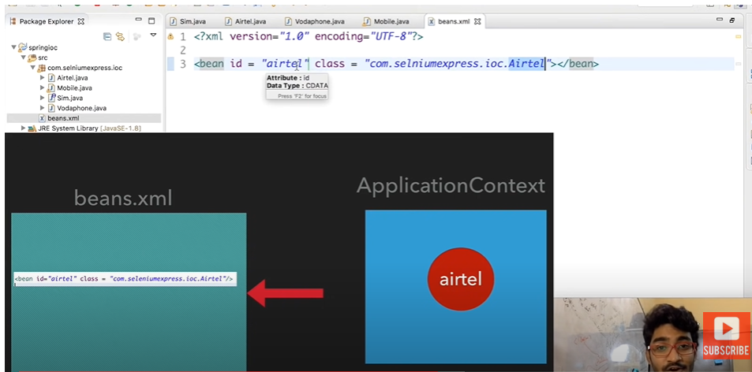

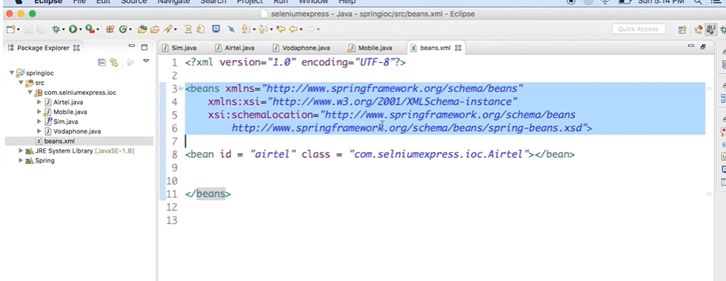

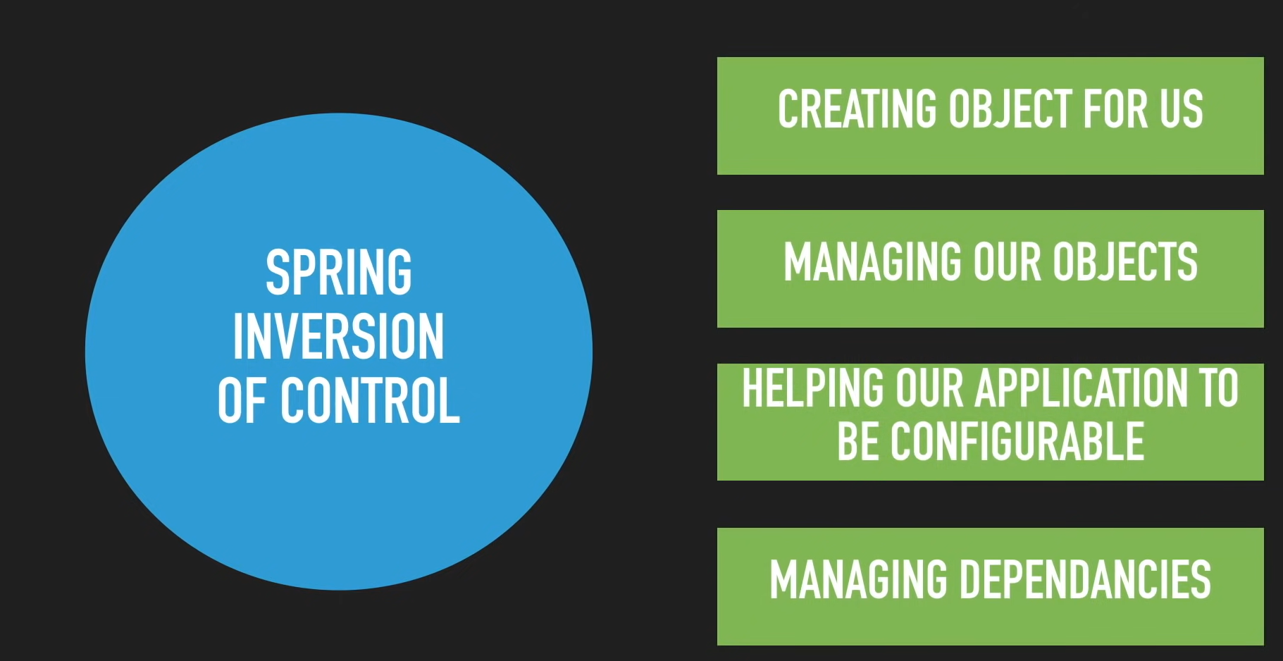

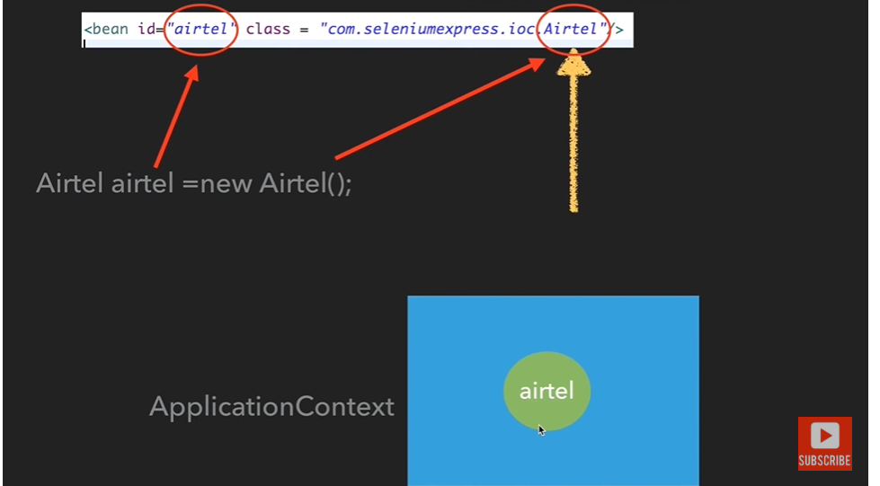

Dependency injection : means injecting dependencies, spring is going to inject the values to the dependencies.

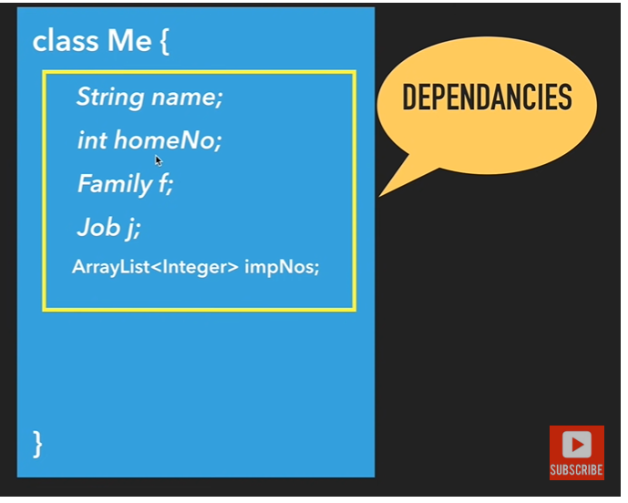

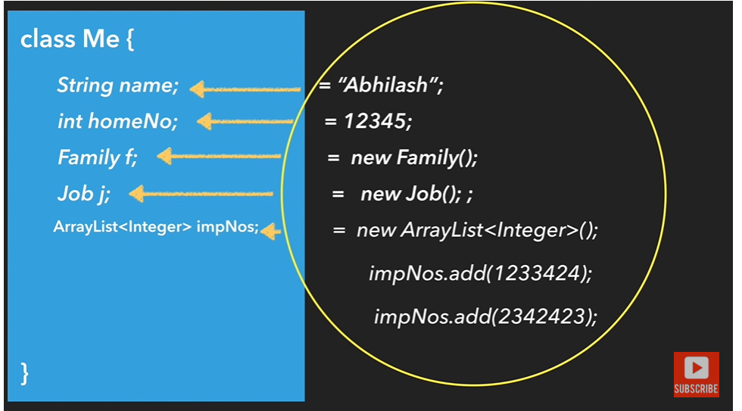

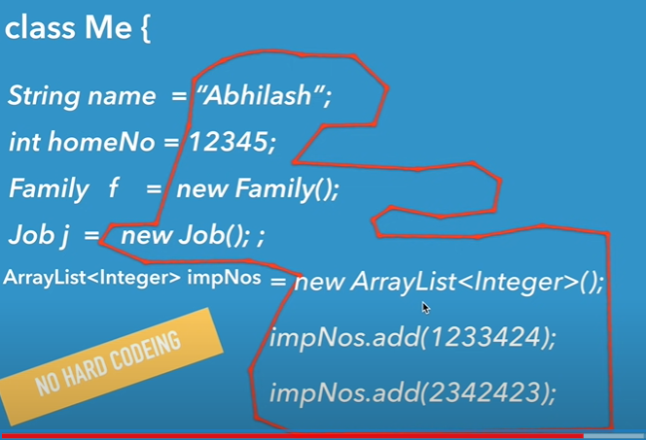

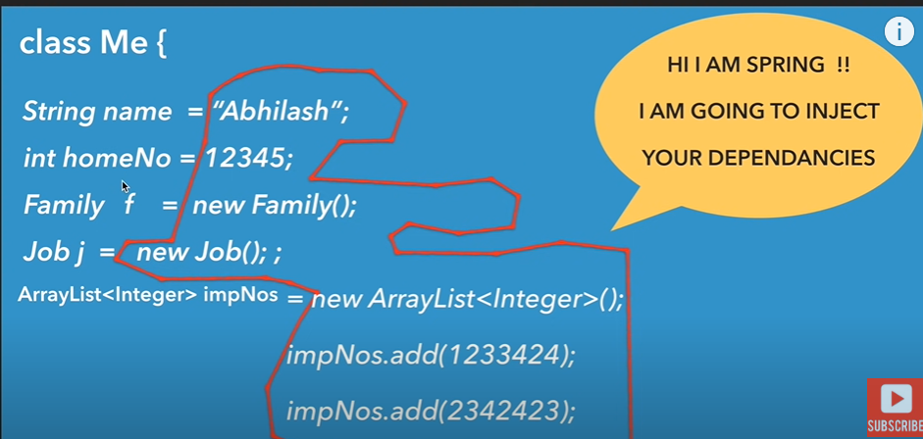

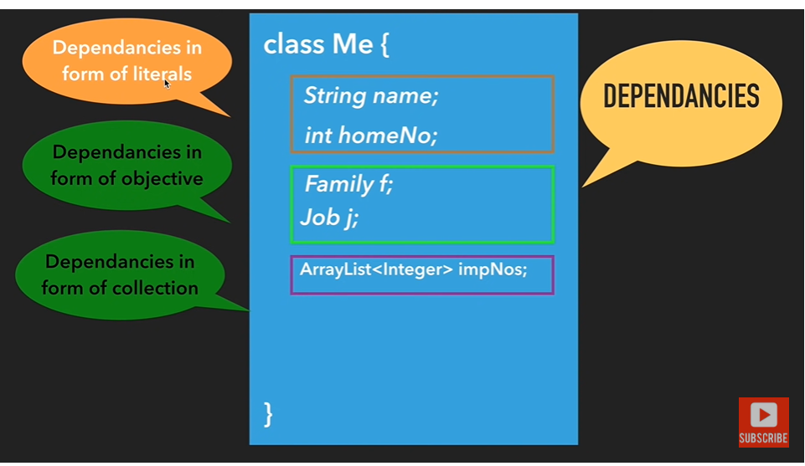

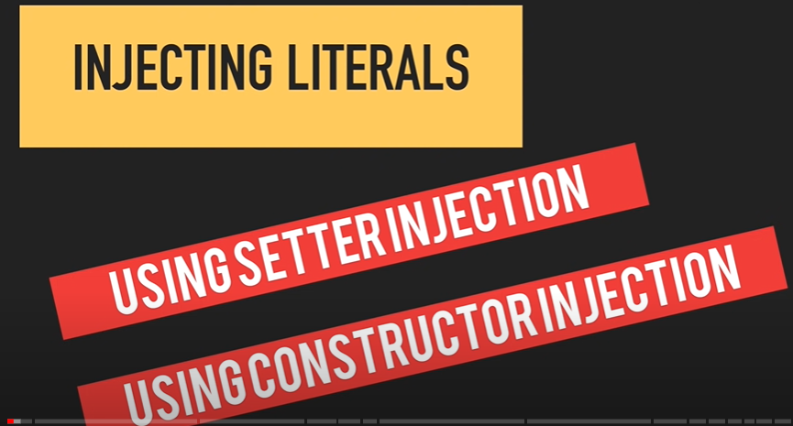

Using setter injection: here IOC container will create object for student class and it will add dependency to studentName.

And it will return student object with help of getBean(“student”) method.

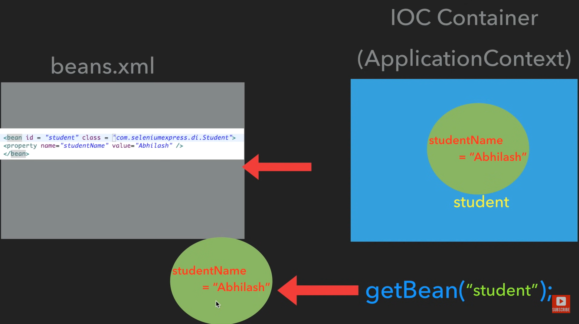

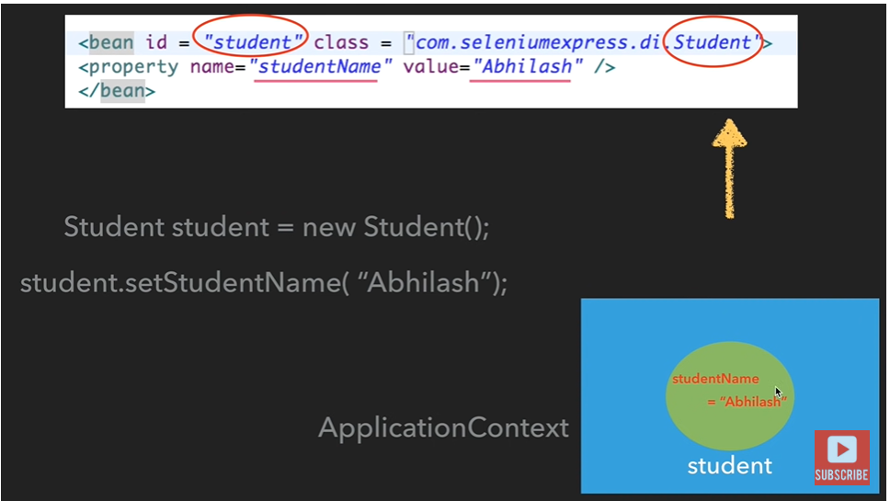

Dependency in the form of object type(Class ref)

